TREE AND FORM VIEWS

When using the system, you will be dealing with these Tree and Form views. Below are the sample and explanation how to use these.

Tree View
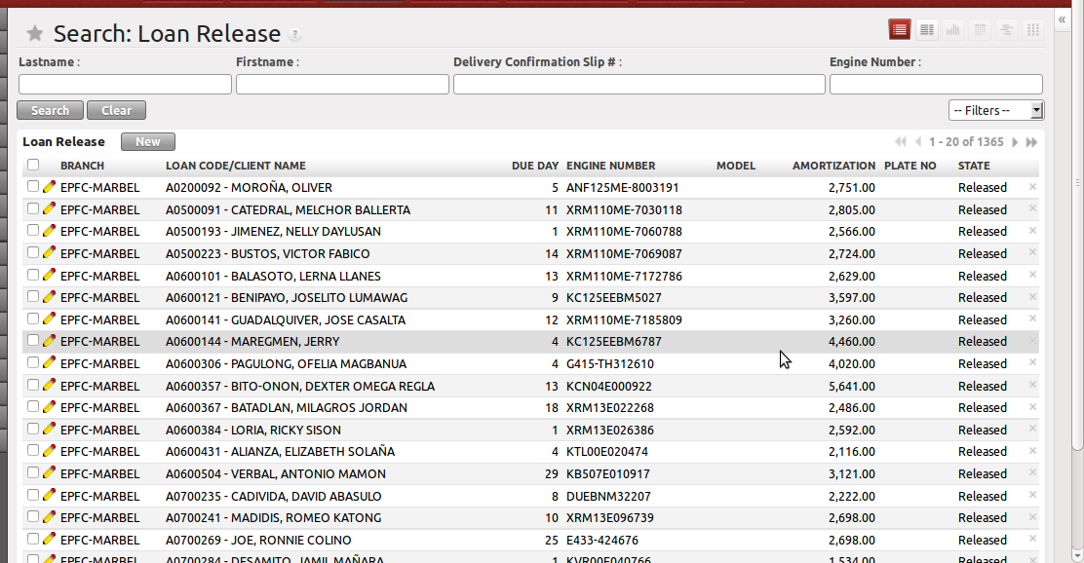

When you click the Client sub menu, this Client Tree View will appear. This view lists down all the records.

Search
You can search records depending on the provided search fields on the upper part of the screen. Simply type your search string on the search field and press Enter Key or click the Search Button

Form View
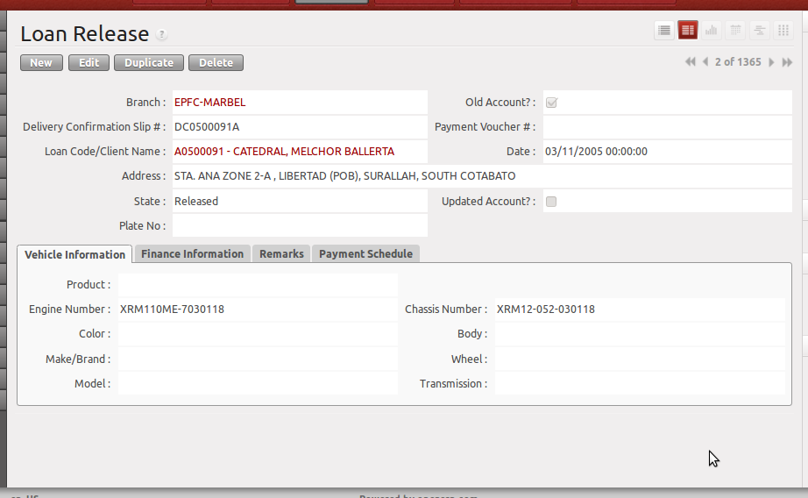
When you click a single record from the Tree View, it will switch you to the Form View of that record. You will see all the details not shown in the tree view. In Form View, you can add or edit a record if you are allowed to.

Also, when clicking the Add button in the Tree View, it will switch you to Form View for you to add a new record.

Others
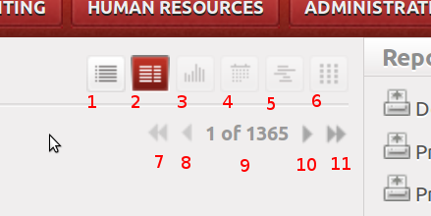

When you click the following, you will be switched to:

1 → Tree View
2 → Form View
3 → Graph View (not discussed. Will be enabled if there is graph report for this model)
4 → Calendar View (not discussed)
5 → Gantt View (not discussed)
6 → Diagram View (not discussed)
7 → Go to First Record
8 → Go to Previous Record
9 → Record number indicator
10 → Go to Next Record
11 → Go to Last Record

